

Mini Project Report

on

**Medi-Scheduler**

For the course

**Web Programming Laboratory**

Submitted by

**Oshan Shah**

Roll No: 16010123223

**Paaras Kokate**

Roll No: 16010123224

**Purab Madhan**

Roll No: 16010123242

Guide

### Mrs. Bharathi Narayan

**Department of Computer Engineering**

**K. J. Somaiya School of Engineering**

**Somaiya Vidyavihar University**

**DECLARATION**

I declare that the written Mini Project report submission represents the work done based on my and / or others’ ideas with adequately cited and referenced the original source. I also declare that I have adhered to all principles of academic honesty and integrity as per norms of the Somaiya Vidyavihar University. I have not misinterpreted, fabricated, or falsified any idea/data/fact/source/original work/matter in my submission.

I understand that any violation of the above will be cause for disciplinary action by the university and may evoke the penal action from the sources which have not been properly cited or from whom proper permission is not sought.

|  |  |
| --- | --- |
| **Roll NO: 16010123223**  **Student Name: Oshan Shah**  **Signature**  C:\Users\STUDENT\Downloads\b755c55b-6d04-452b-9f32-e2e7bb5d0033 (1).jpg | **Roll NO: 16010123224**  **Student Name:Paaras Kokate**  **Signature**  C:\Users\STUDENT\Downloads\b755c55b-6d04-452b-9f32-e2e7bb5d0033.jpg |
| **Roll NO: 16010123242**  **Student Name: Purab Madhan**  **Signature** C:\Users\STUDENT\Downloads\IMG_5913.jpg | **Roll NO:**  **Student Name:**  **Signature** |

**Date: 17 – 04 - 2025**

**Place: Mumbai-77**

**INDEX**

1. Application Web Development: Title Page 5
2. Literature Review about Application (With references)
   * 1. Need Statement Page 5
3. Objectives Page 6
4. Flow of pages  : login , catalogue, menus ,feedback ,etc Page 9 -15
5. Figma design, Database Schema page 15-18
6. Conclusion Page 18 - 20

1. Future scope Page 20

**Acknowledgement**

We would like to express our heartfelt gratitude to **Mrs. Bharathi Narayan**, our esteemed guide and faculty member, for her invaluable support, expert guidance, and constant encouragement throughout the development of our mini project titled *"Medi Scheduler – A Web-Based Healthcare Appointment and Record Management System."* Her deep knowledge, constructive feedback, and approachable nature made the learning process insightful and engaging. It was truly a privilege to work under her mentorship.

We are also thankful to the **Department of Computer Engineering**, **K. J. Somaiya College of Engineering**, for giving us the opportunity to undertake this project and providing all the necessary facilities, academic environment, and technical resources.

We would also like to acknowledge the contributions of our fellow classmates and team members, whose cooperation and teamwork played a crucial role in the successful completion of this project. Special thanks to all the individuals who provided feedback during the testing phase, helping us identify areas for improvement.

Finally, we sincerely thank our families and friends for their moral support and motivation throughout the project journey. This experience has been a great stepping stone in our academic and professional development.

### ****Application Web Development: Title****

**Project Title:** Medi Scheduler – A Web-Based Healthcare Appointment and Record Management System

**STATEMENT**

A streamlined healthcare platform like Medi Scheduler is essential to reduce appointment chaos, ensure timely access to specialists, and simplify patient record management in one unified digital system.

### ****Literature Review about Application (With References)****

In recent years, digital healthcare platforms have emerged as crucial tools in streamlining medical services, especially in urban settings where healthcare demand is high. Appointment scheduling systems are now widely adopted to reduce waiting times and enhance the patient experience. Research by Zhang et al. (2017) highlights that online scheduling reduces patient no-shows and optimizes healthcare resource utilization. Furthermore, integrating medical history tracking and billing into such platforms improves operational efficiency and minimizes administrative burden (Chen et al., 2020).

The Medi Scheduler aims to fill the gap in accessible and user-friendly healthcare appointment systems by providing a seamless interface for patients to book consultations with specialists, track their health records, and manage billing efficiently. Studies like Gajanayake et al. (2014) emphasize that centralized digital medical records significantly enhance continuity of care and data accuracy, especially when shared among doctors and administrators in a secure environment.

By merging patient, doctor, and admin functionalities, Medi Scheduler aligns with modern trends in digital health transformation and patient-centric care.

**References**

* Zhang, X., Liu, S., Chen, X., Wang, L., & Gao, B. (2017). Health information technologies: Improving healthcare systems. Journal of Medical Systems.
* Chen, M., Ma, Y., & Li, Y. (2020). Smart health applications and services using big data and cloud computing. Journal of Healthcare Engineering.
* Gajanayake, R., Iannella, R., & Sahama, T. (2014). Sharing health records in patient-centric models: Privacy and access control issues. Journal of Health Informatics.

### ****Objectives of the Project****

The primary objective of the Medi Scheduler project is to develop a web-based platform that streamlines and digitizes healthcare appointment scheduling, patient record management, and billing processes. The specific objectives are:

1. **To provide a user-friendly interface for patients** to register, log in, and book appointments with available specialist doctors with ease.
2. **To enable doctors to view and manage appointments**, access patient health records, and update medical history efficiently.
3. **To allow the admin to oversee system-wide activities**, including generating bills, maintaining patient visit history, and managing user accounts.
4. **To maintain a centralized and secure database** that stores user details, appointment logs, health records, and billing data.
5. **To reduce manual workload and errors** typically associated with traditional appointment and record-keeping systems.
6. **To improve the accessibility and convenience** of healthcare services for both patients and healthcare providers through a digital solution.

Relational Schema

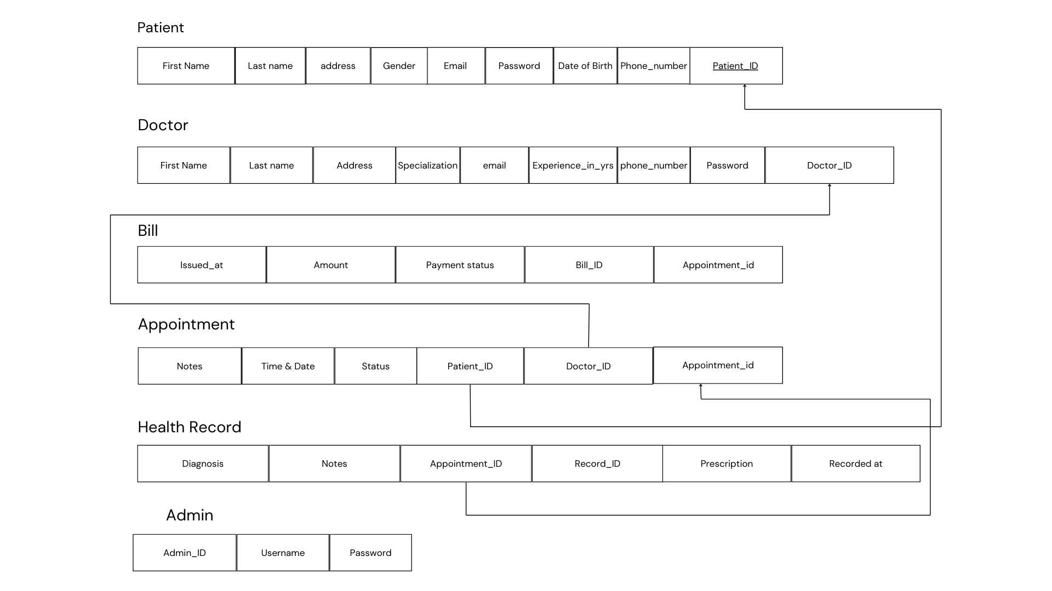

Database Schema

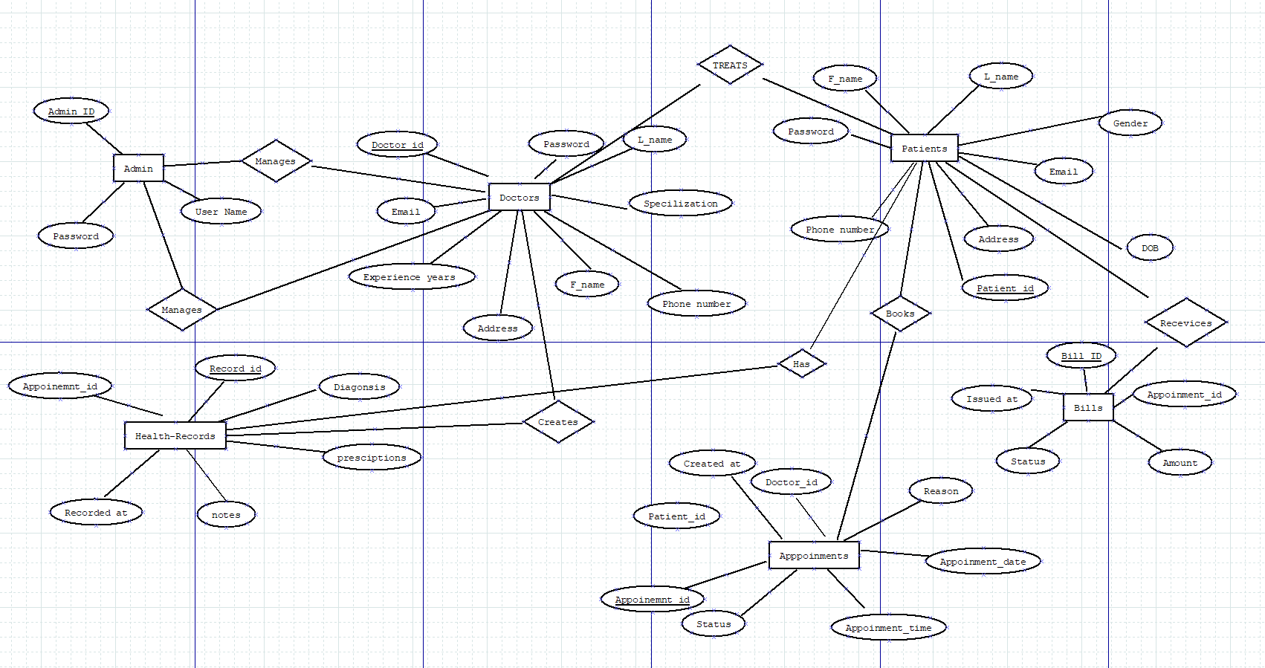

Website Images

Landing page:

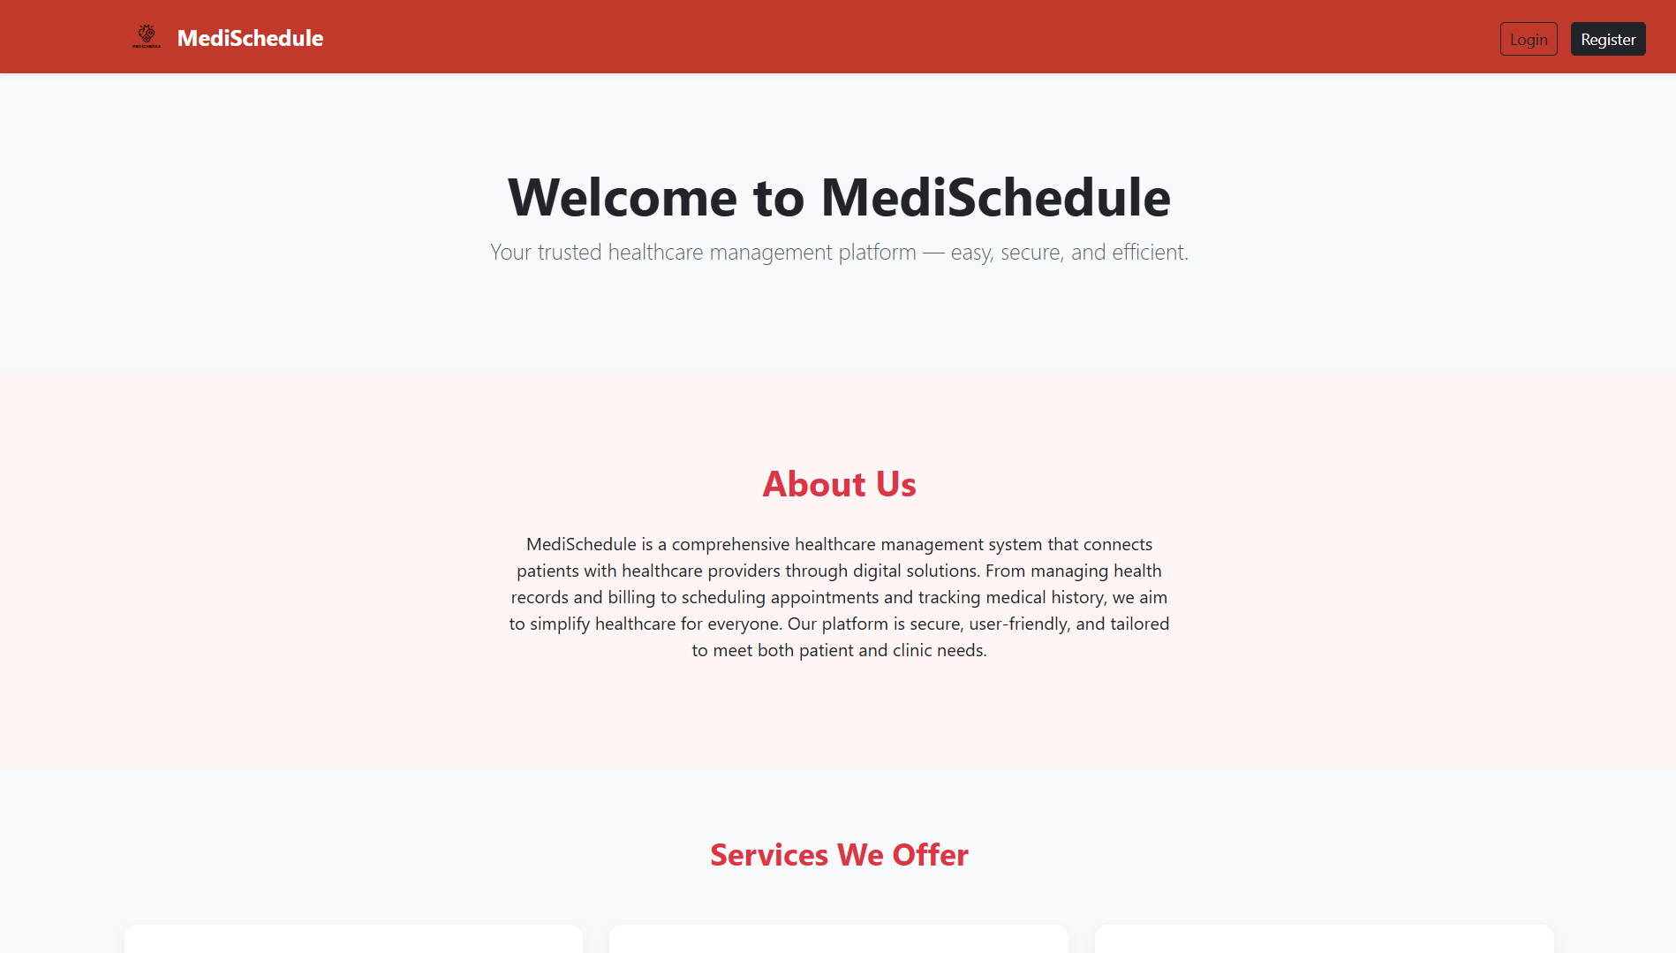

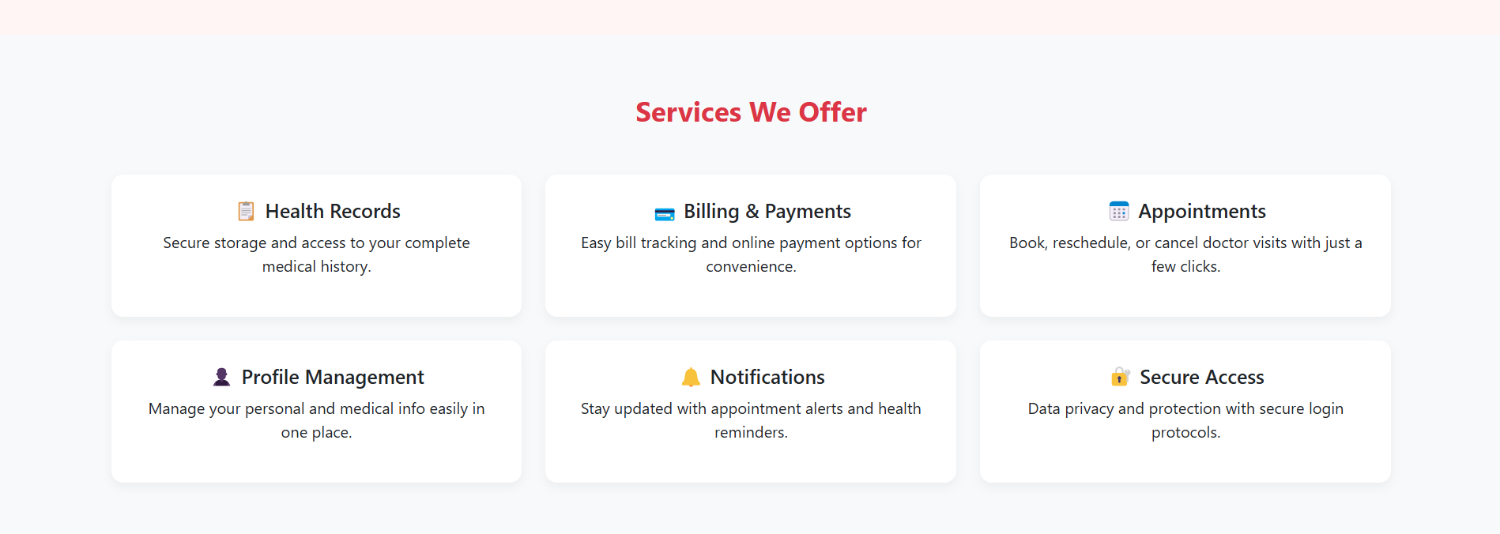

Patient Login:

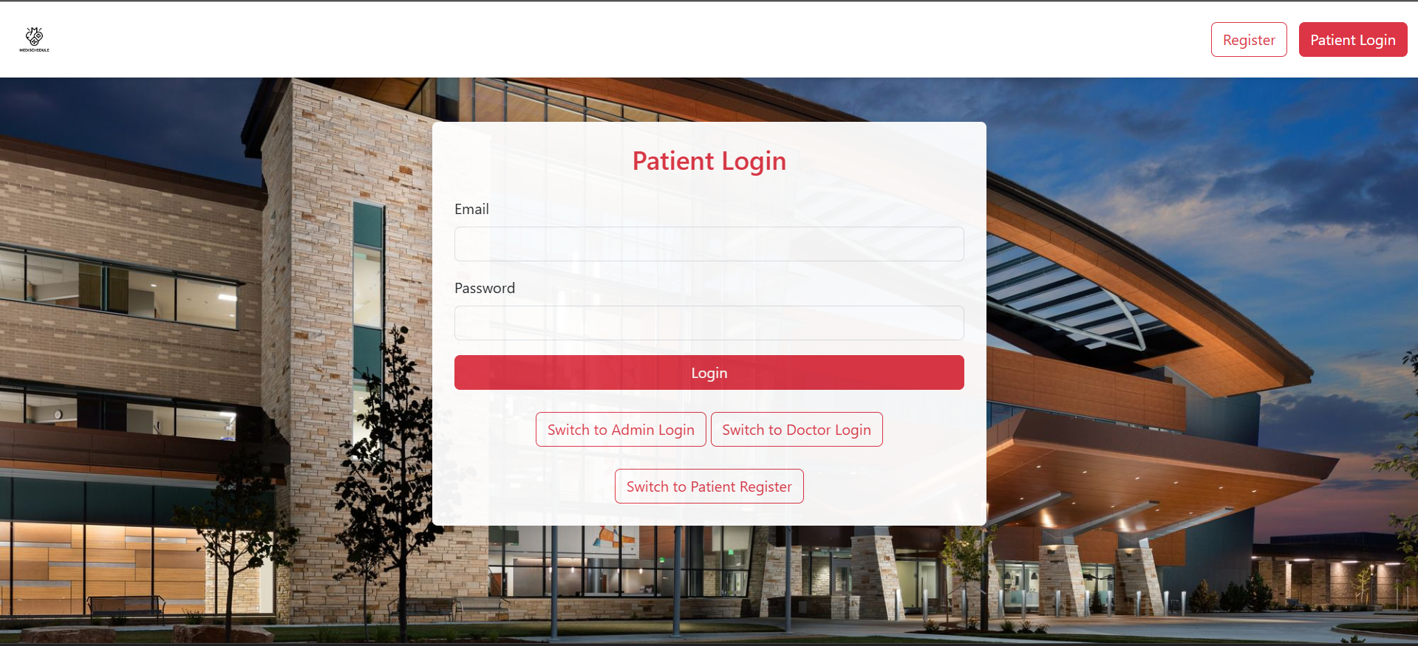

Register for Patients: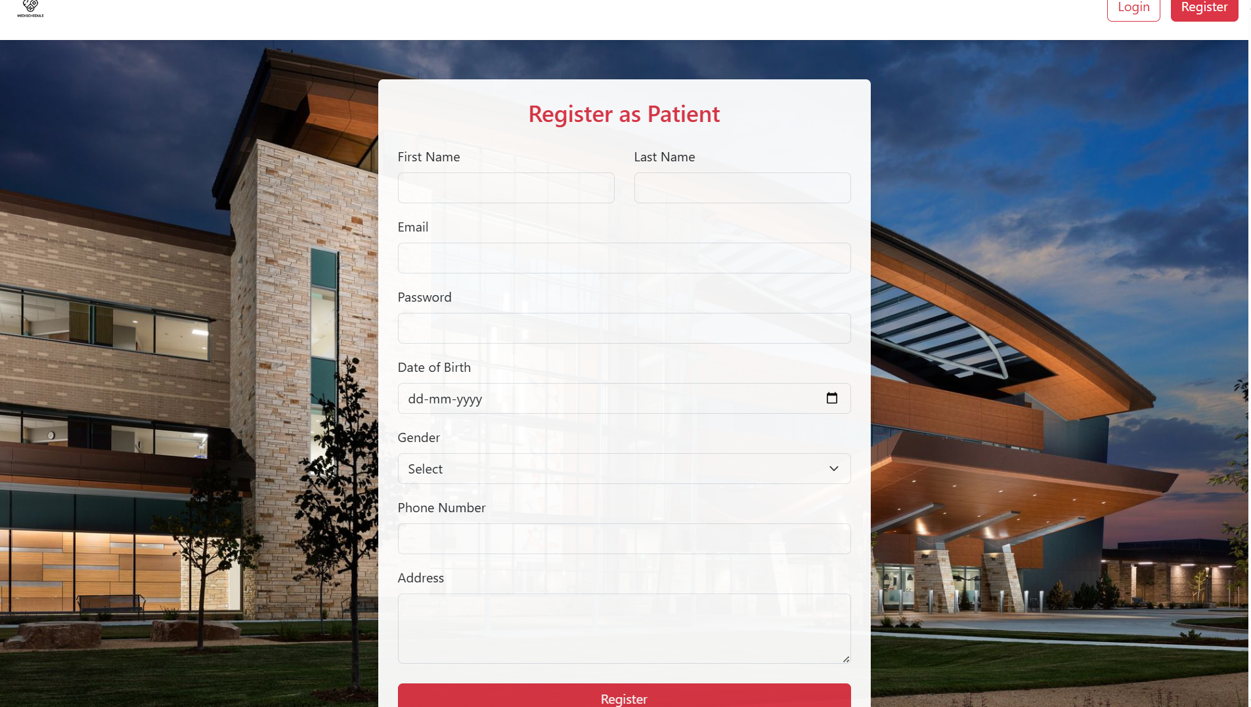

Doctor login page: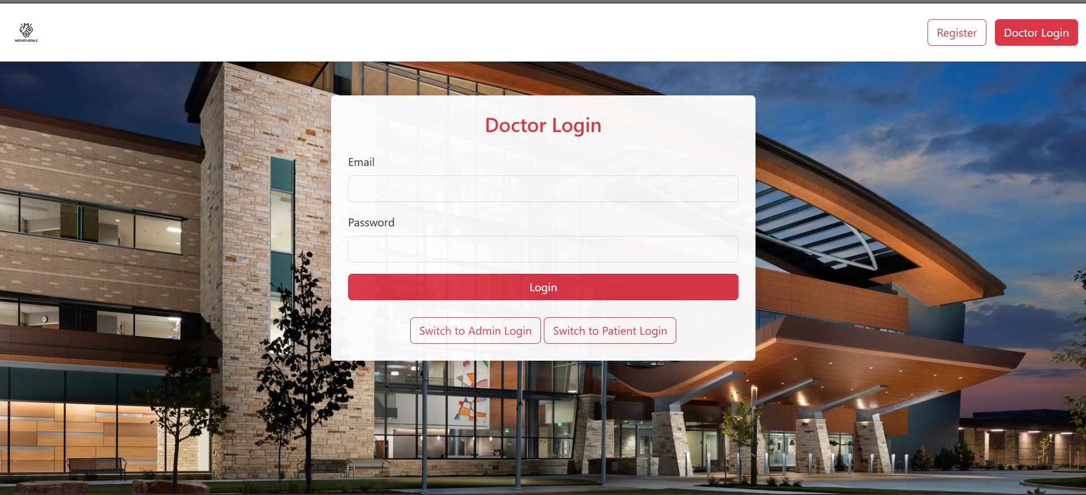

Admin Login page:

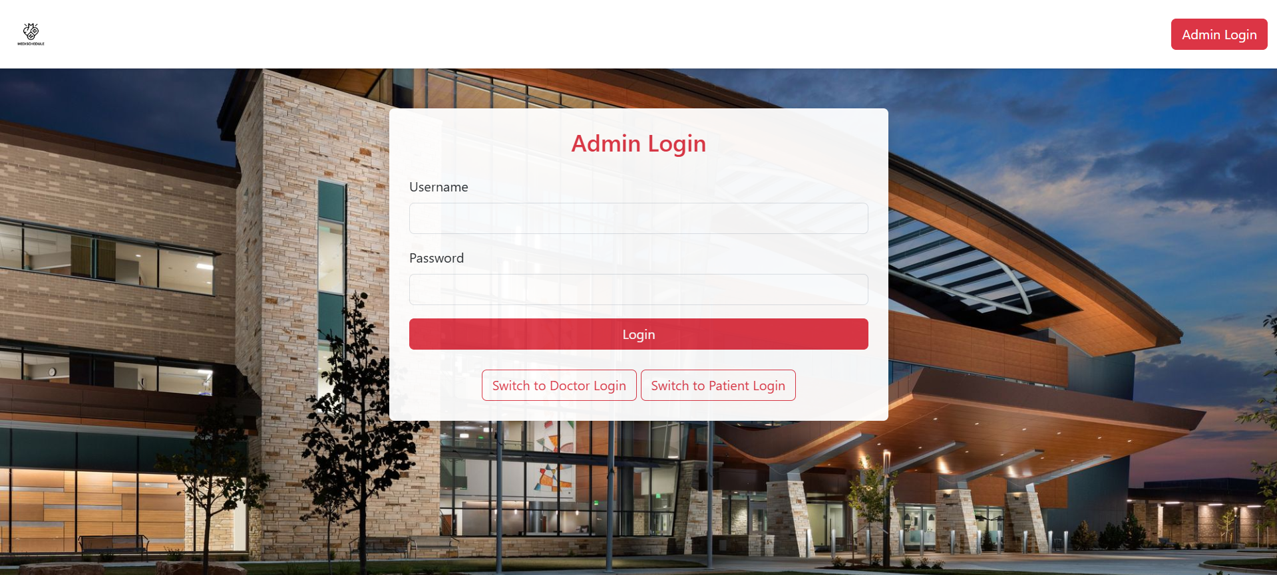

Admin Control Panel:

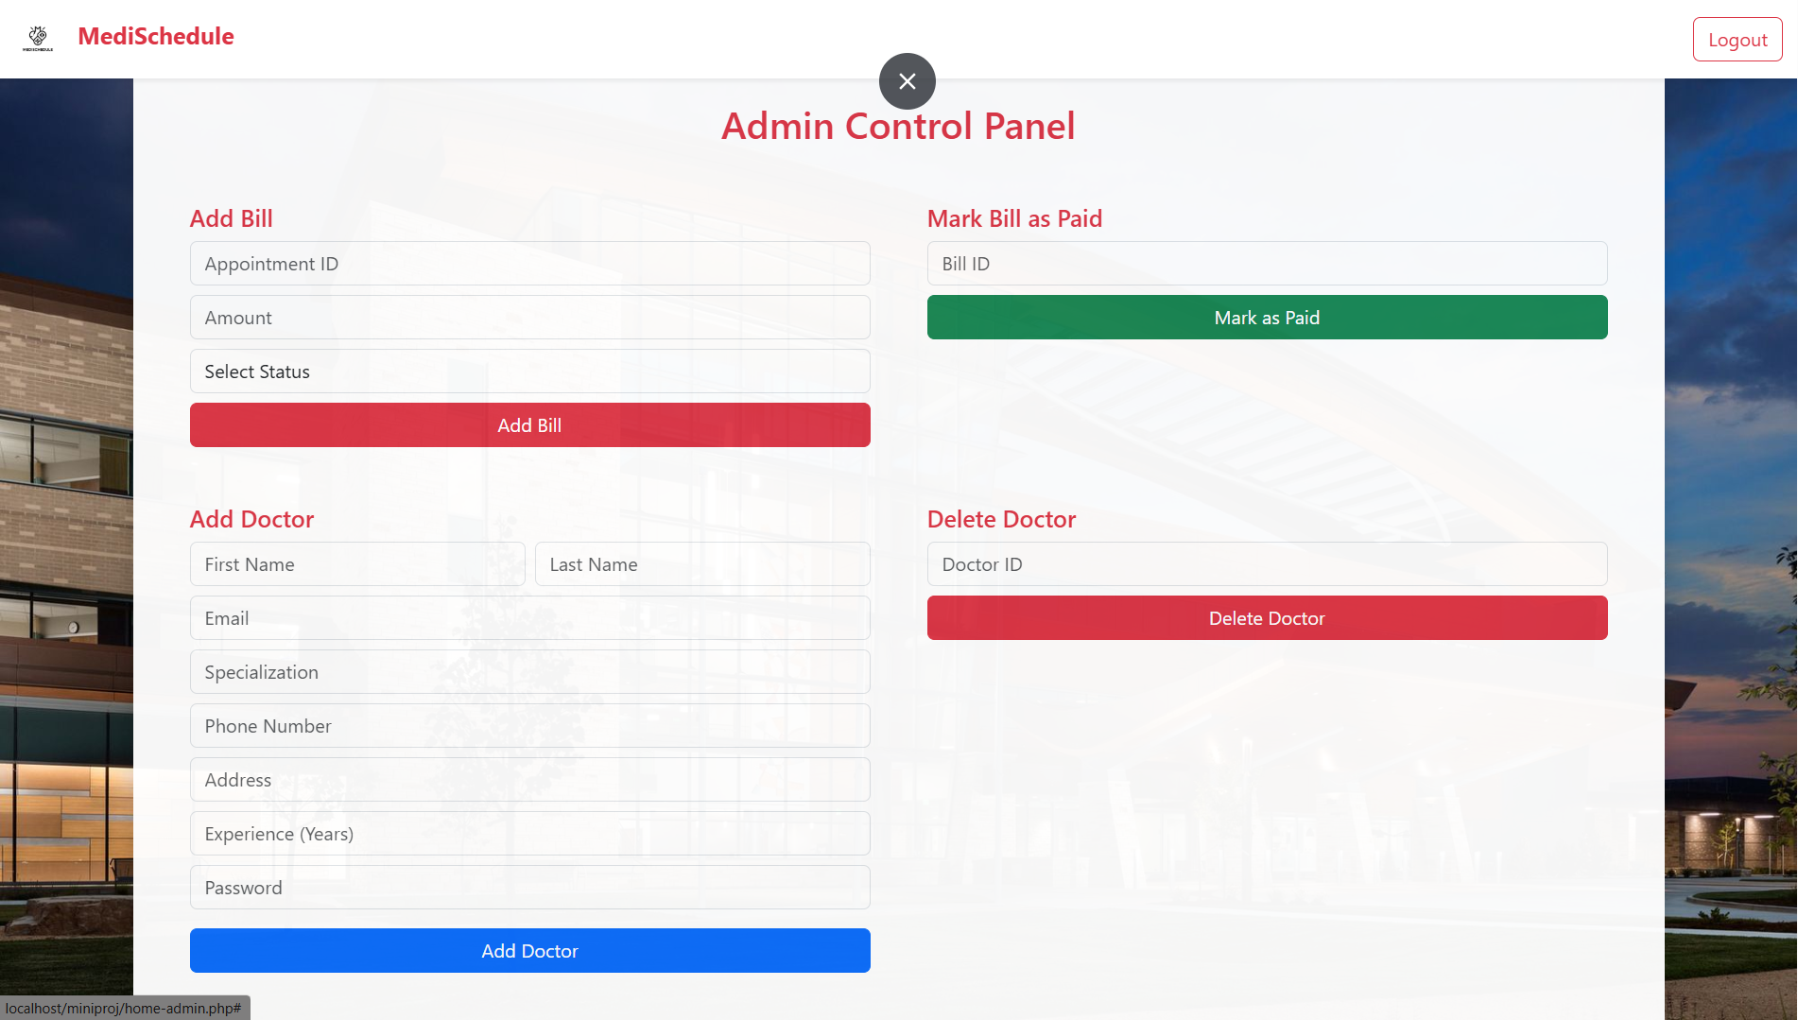

Dashboard of Patients:

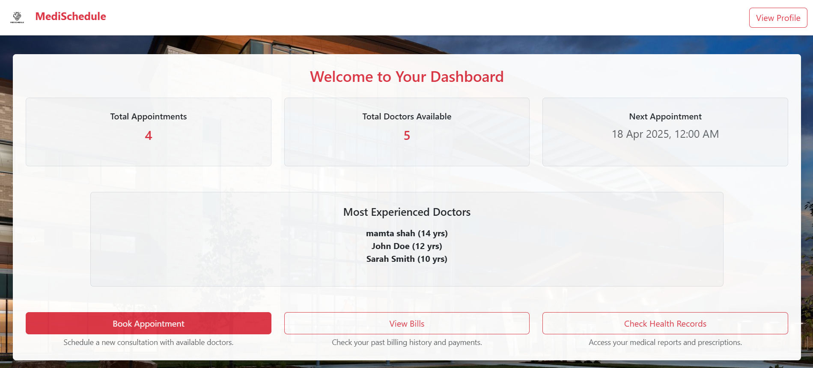

Patient’s Profile: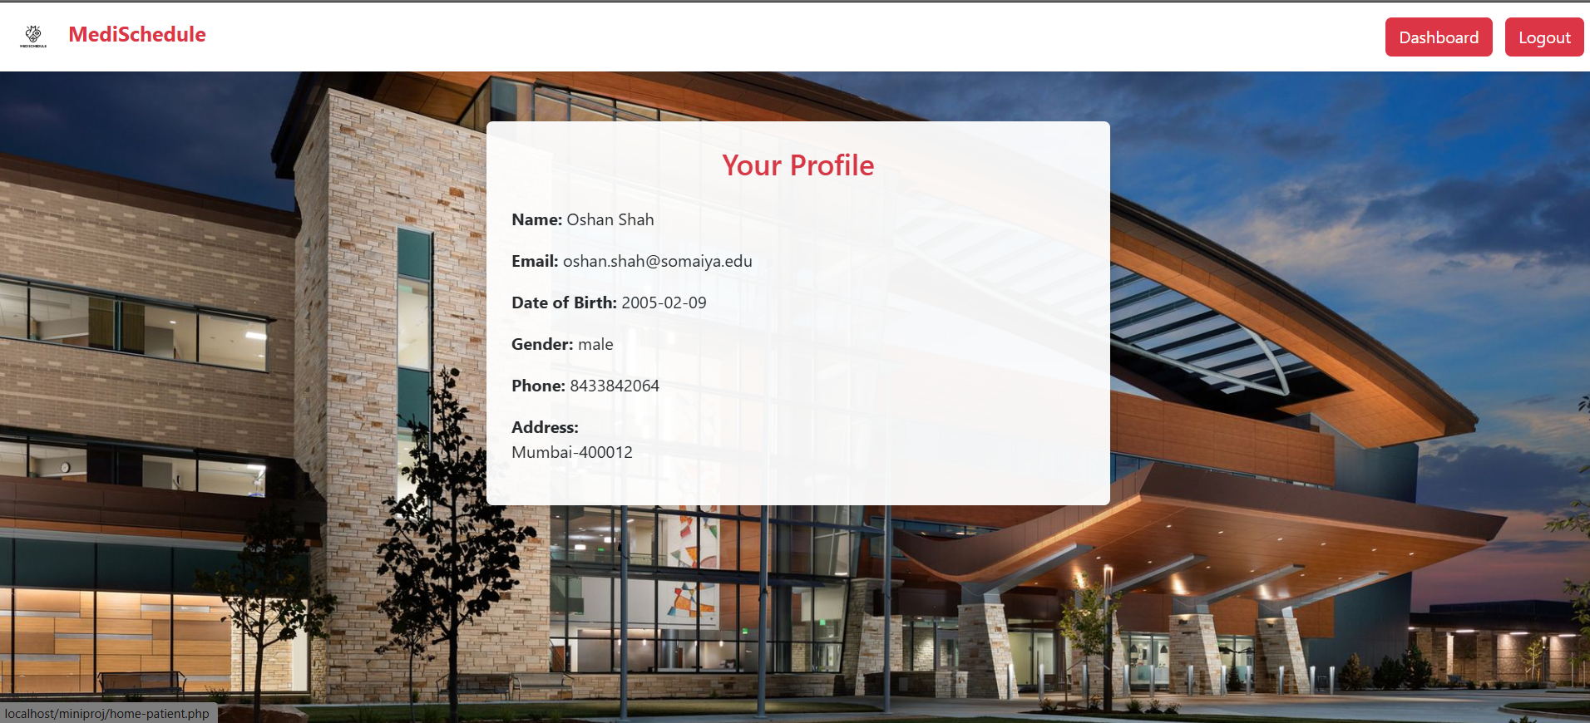

Booking an Appointment:

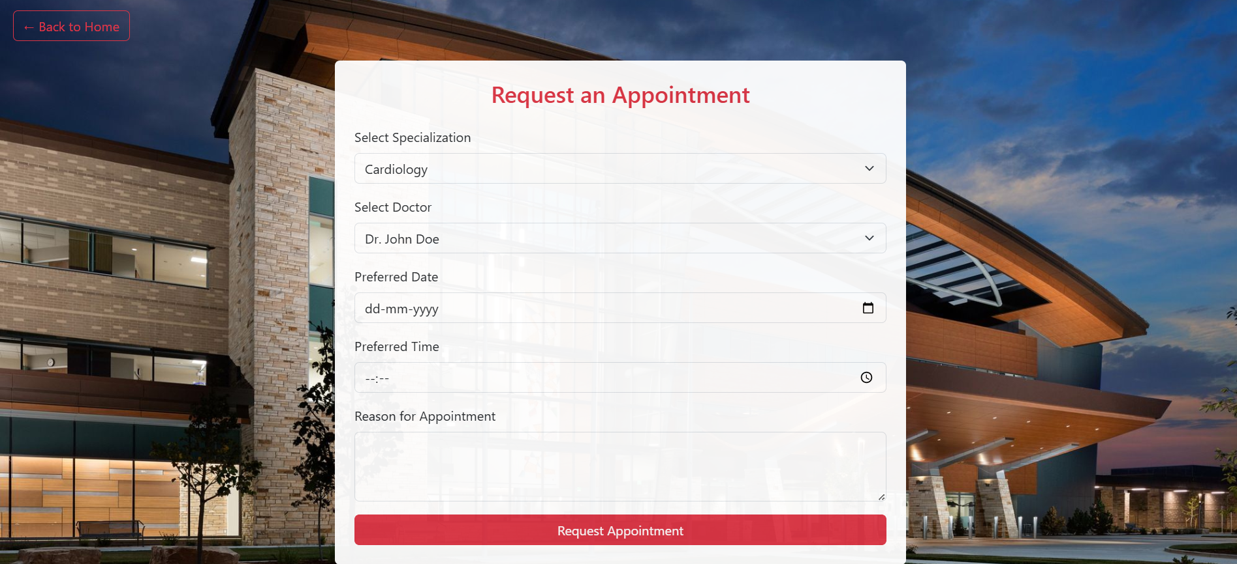

View bills: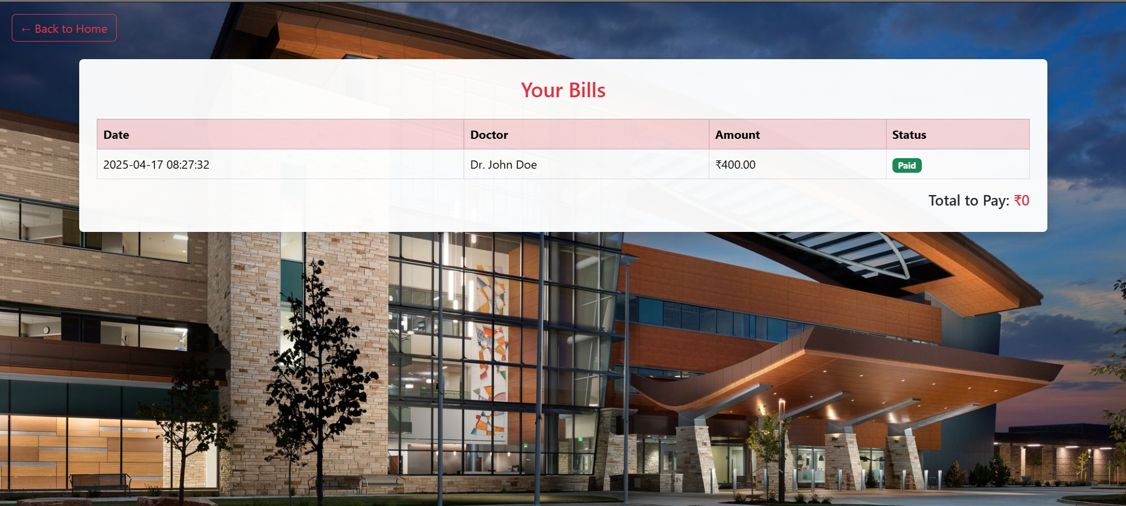

Viewing your Helath-Records: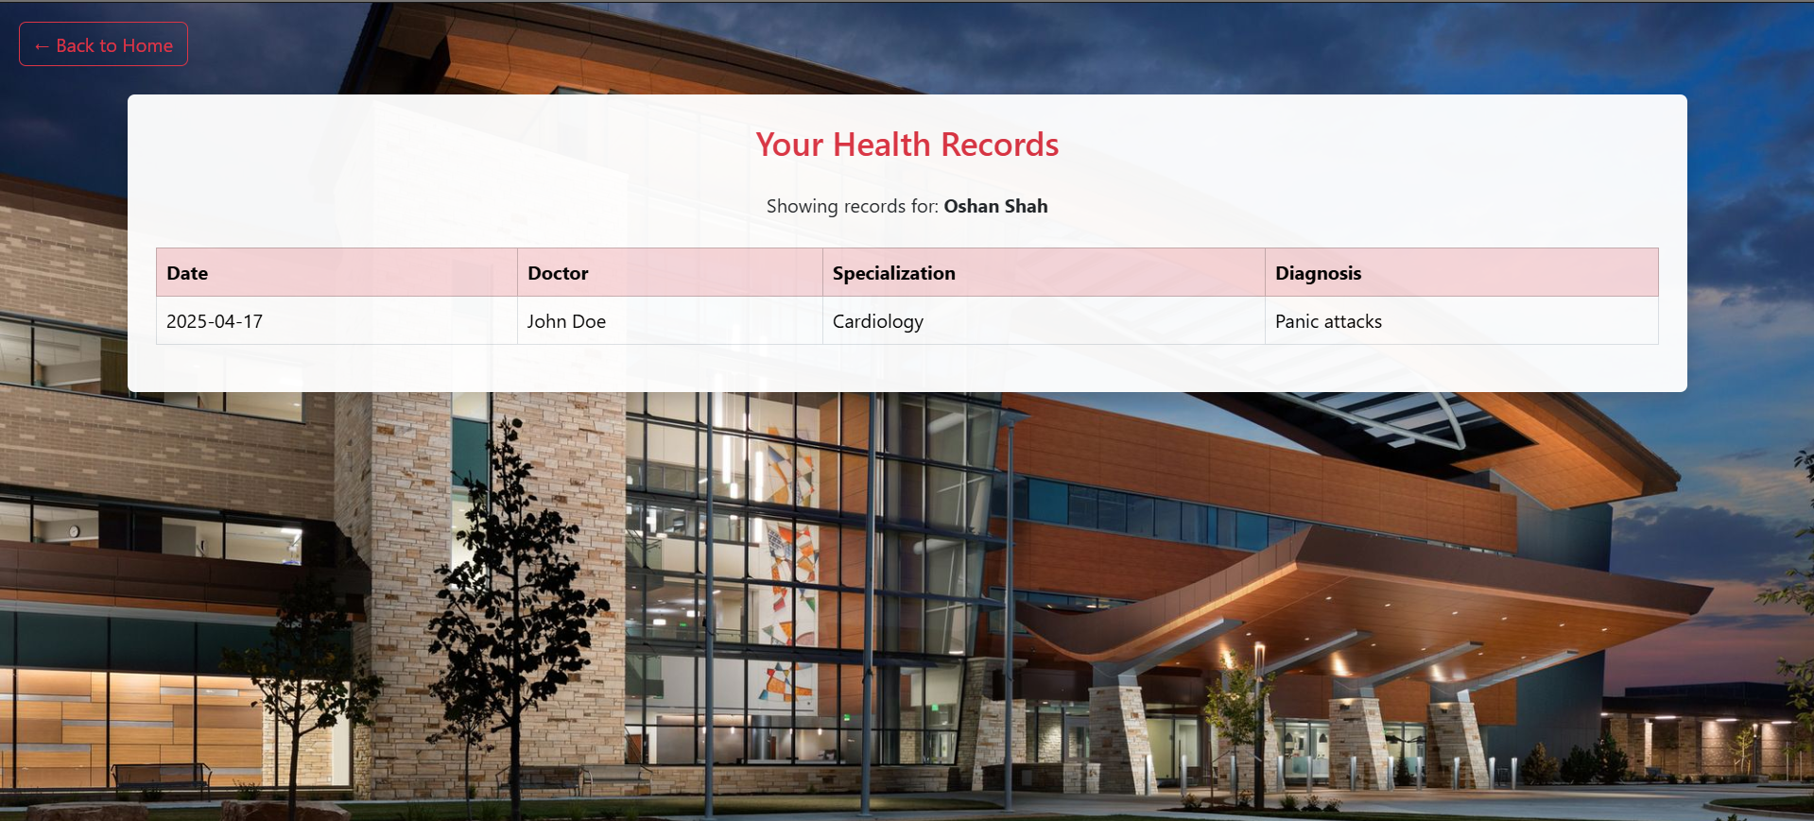

Dashboards for Doctors: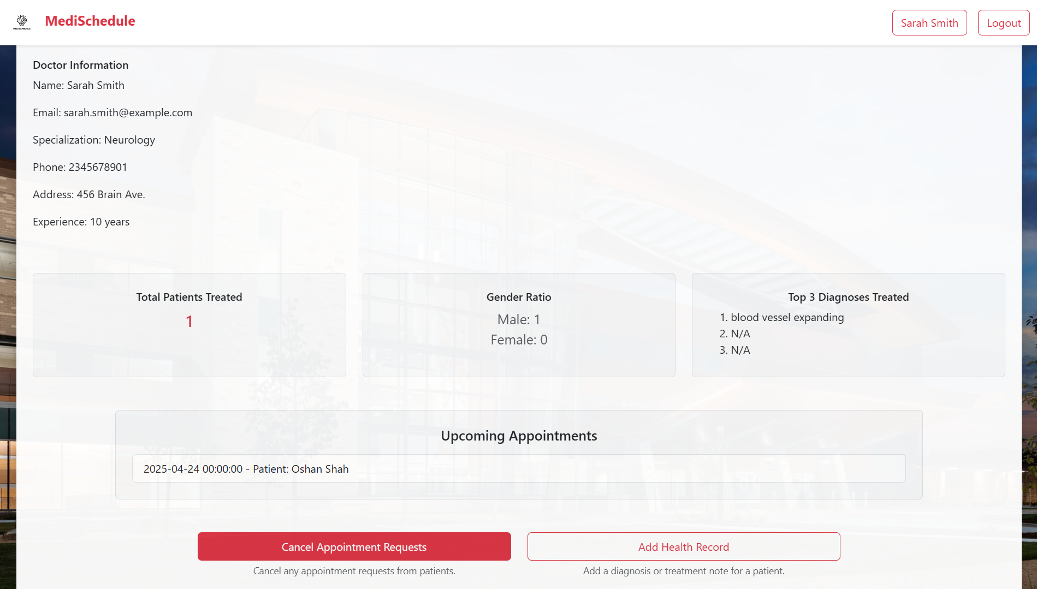

Upcoming Appointments for Doctors: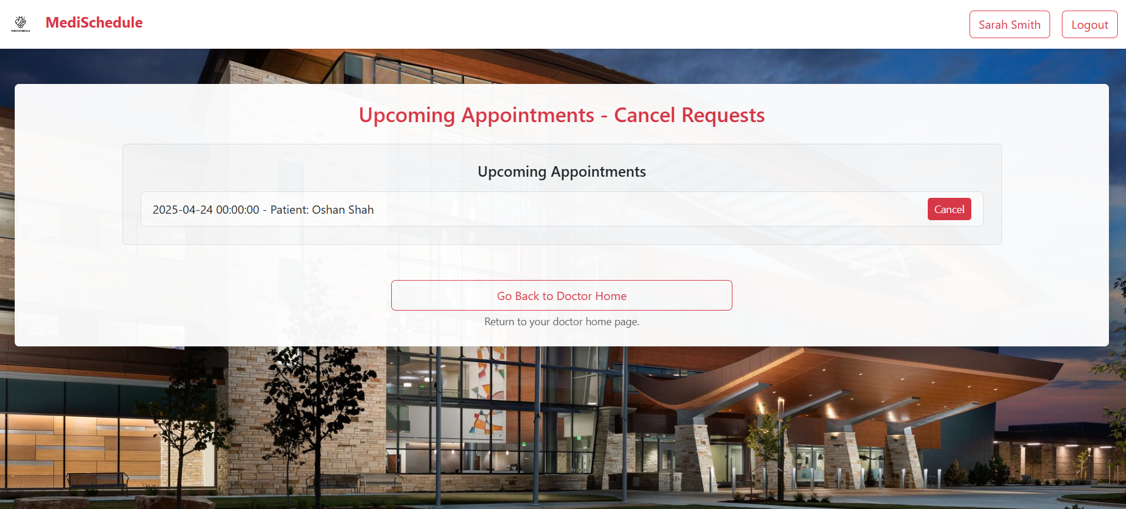

Updating Health-Records: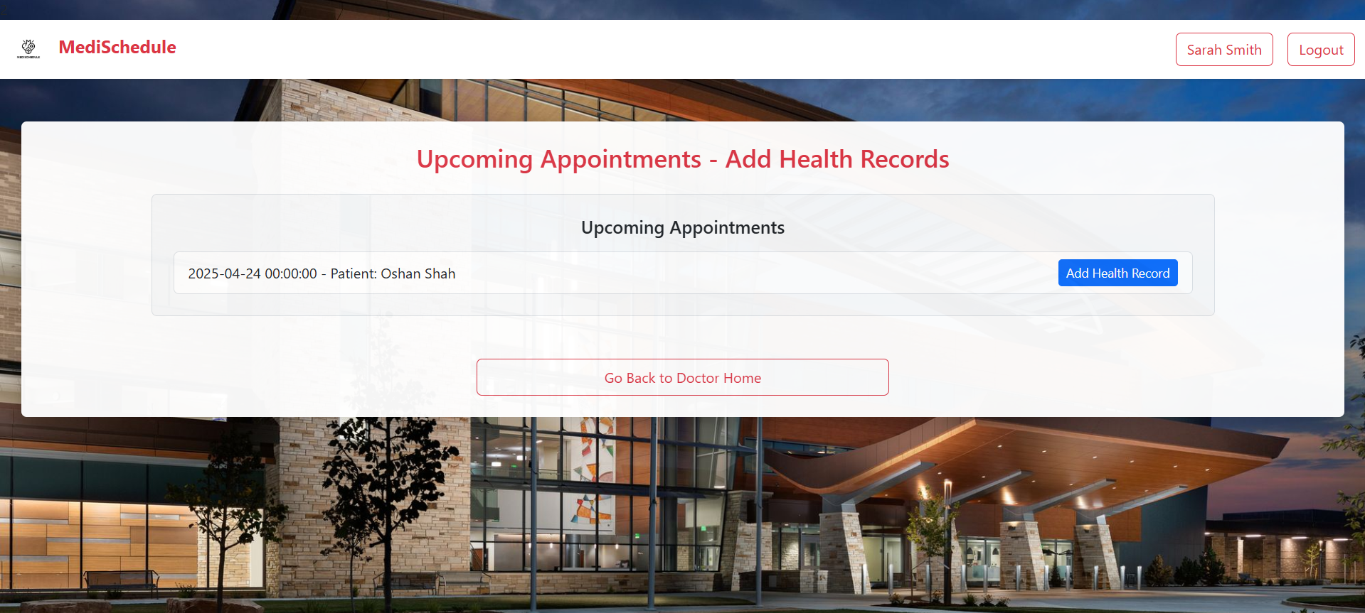

DATABASE TO THE WEBSITE

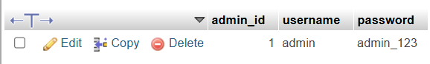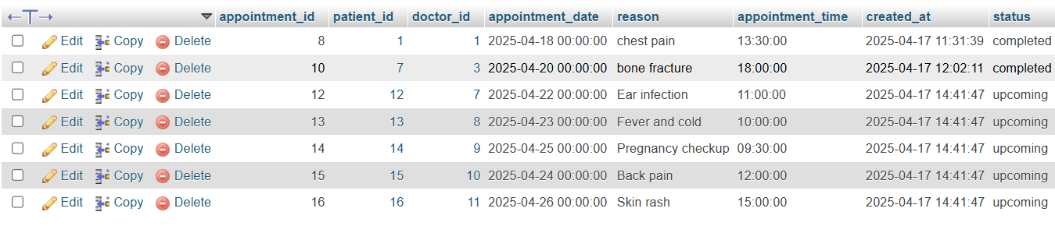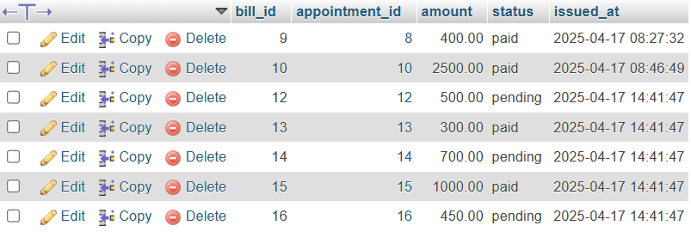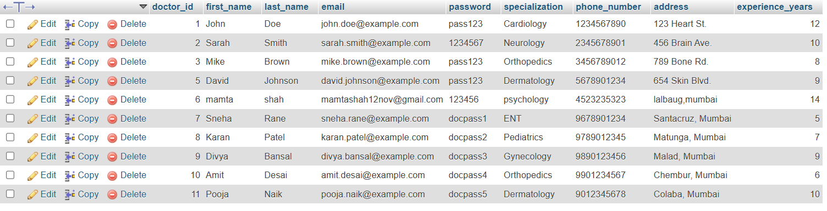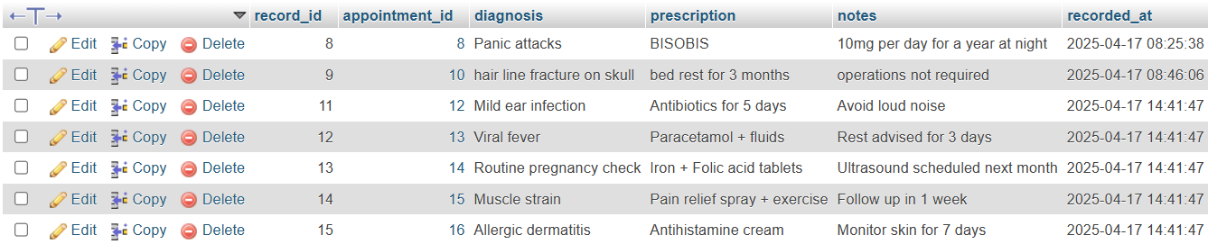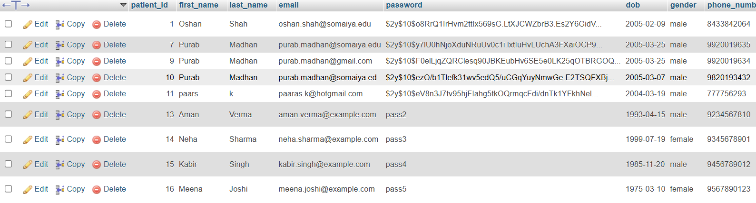

Figma Design

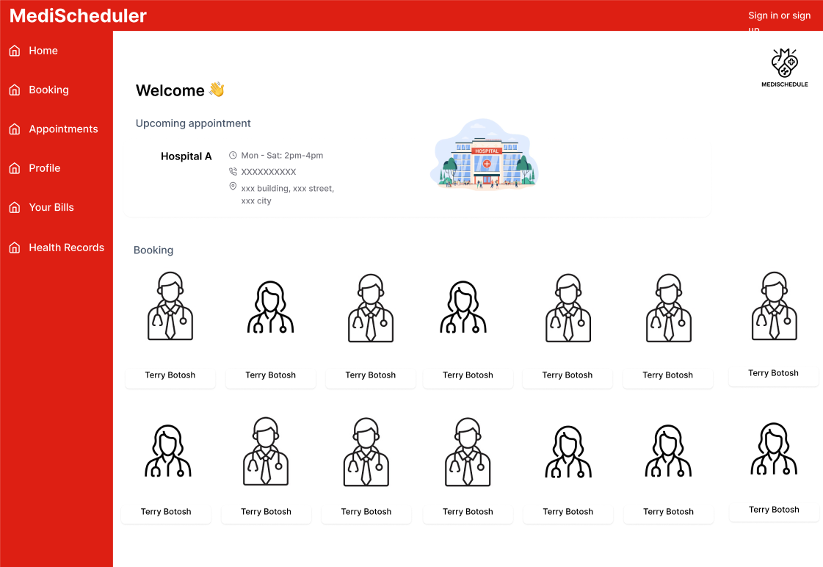

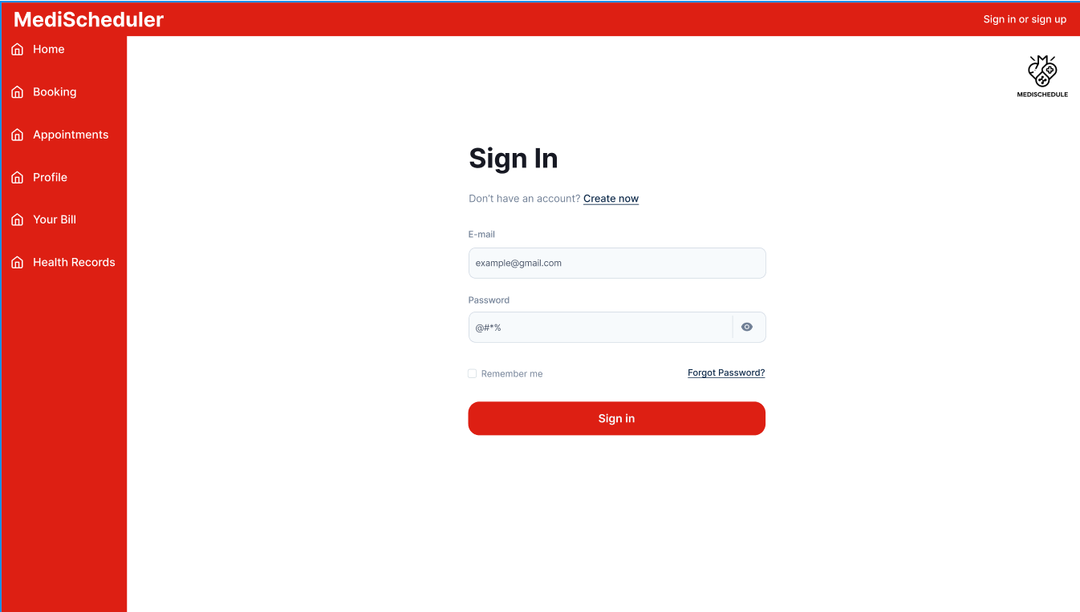

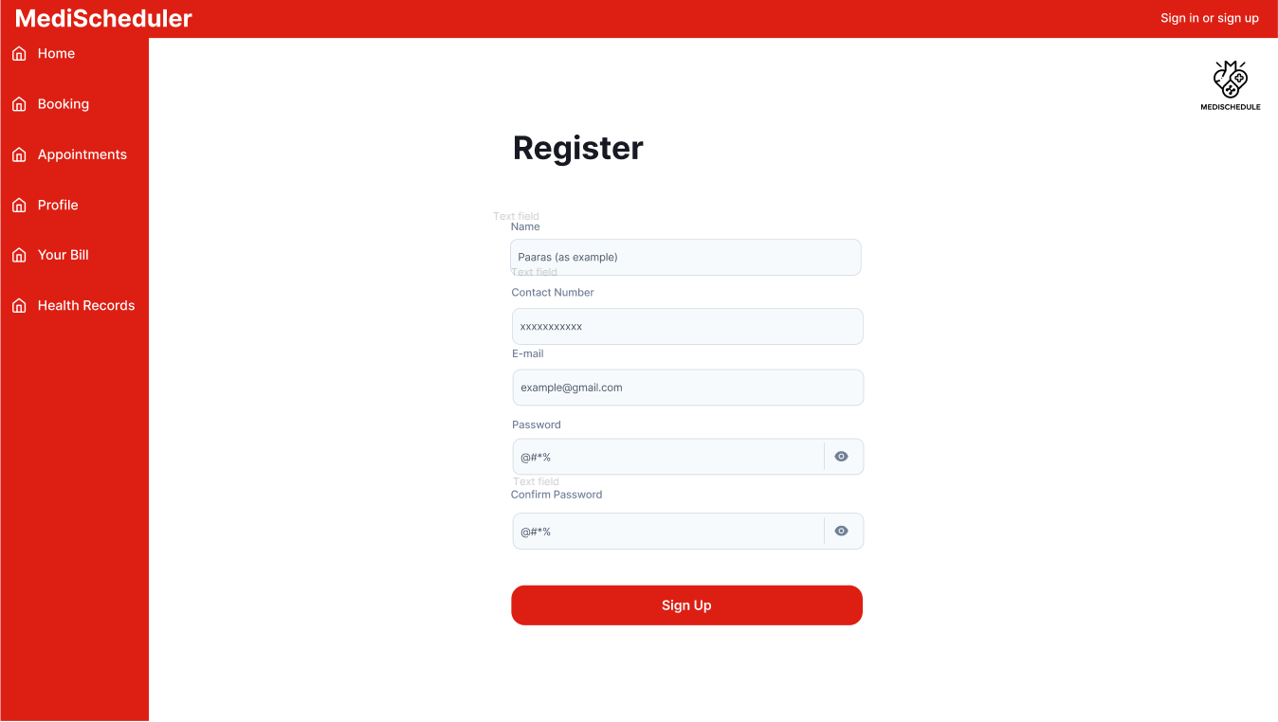

Relational Schema



Database Schema



### ****Conclusion****

The Medi Scheduler project successfully addresses the growing need for a digital, efficient, and user-friendly healthcare management system. By integrating patient appointment booking, doctor interaction, health record tracking, and administrative billing functionalities into a single platform, the system enhances the overall experience for all stakeholders involved. It reduces the dependency on manual processes, minimizes scheduling conflicts, and ensures better continuity of care through accurate and centralized health records.

The project not only contributes to the ongoing digital transformation of healthcare services but also demonstrates the practical application of web development and database management in solving real-world problems. Moving forward, Medi Scheduler has the potential to be expanded with features like prescription uploads, notification systems, and teleconsultation integration to further strengthen its impact in the healthcare domain.

### ****Future Scope****

The Medi Scheduler platform lays the foundation for a scalable and robust healthcare management system. In the future, the following enhancements can be implemented to improve its functionality and reach:

1. **Telemedicine Integration**: Enabling video consultations for remote patient care, especially useful in rural or inaccessible areas.
2. **Automated Reminders**: Incorporating SMS and email reminders for upcoming appointments, medication schedules, and follow-up visits.
3. **E-Prescription Module**: Allowing doctors to generate and share digital prescriptions with patients and nearby pharmacies.
4. **AI-Based Doctor Recommendation**: Suggesting suitable specialists to patients based on symptoms, availability, and previous visits.
5. **Payment Gateway Integration**: Facilitating secure online payments for consultations and medical services.
6. **Mobile Application Development**: Creating an Android/iOS app to increase accessibility and provide a seamless user experience on smartphones.
7. **Multi-language Support**: Enhancing user-friendliness by offering the platform in regional languages.
8. **Analytics Dashboard**: Providing detailed insights to admins and doctors for better decision-making and service optimization.

These advancements would further improve the system's efficiency, accessibility, and overall value to both healthcare providers and patients.

]

Github Repository link:  
**https://github.com/oshanshah/wplminiprojet**